VISVESVARAYA TECHNOLOGICAL UNIVERSITY

**“JnanaSangama”, Belgaum -590014, Karnataka.**



**LAB REPORT**

**On**

**ANALYSIS AND DESIGN OF ALGORITHMS (23CS4PCADA)**

**Submitted by**

**VIJETH M D (1WA23CS041)**

**in partial fulfillment for the award of the degree of BACHELOR OF ENGINEERING**

**in**

**COMPUTER SCIENCE AND ENGINEERING**



**B.M.S. COLLEGE OF ENGINEERING**

**(Autonomous Institution under VTU) BENGALURU-560019**

**February-May 2025**

**B. M. S. College of Engineering,**

**Bull Temple Road, Bangalore 560019**

**(Affiliated To Visvesvaraya Technological University, Belgaum) Department of Computer Science and Engineering**



This is to certify that the Lab work entitled **“ANALYSIS AND DESIGN OF ALGORITHMS”** carried out by VIJETH M D**(1WA23CS041)**, who is bonafide student of **B. M. S. College of Engineering**. It is in partial fulfillment for the award of **Bachelor of Engineering in Computer Science and Engineering** of the Visvesvaraya Technological University, Belgaum during the year 2024-25. The Lab report has been approved as it satisfies the academic requirements in respect of Analysis and Design of Algorithms Lab - **(23CS4PCADA)** work prescribed for the said degree.

**Prof. Vikranth B M Dr. Kavitha Sooda**

Assistant Professor Professor and Head

Department of CSE Department of CSE

BMSCE, Bengaluru BMSCE, Bengaluru

**Index Sheet**

|  |  |  |
| --- | --- | --- |
| **Sl.**  **No.** | **Experiment Title** | **Page No.** |
| 1 | Write program to obtain the Topological ordering of vertices in a given digraph.  LeetCode Program related to Topological sorting | 5-9 |
| 2 | Implement Johnson Trotter algorithm to generate permutations. | 10-12 |
| 3 | Sort a given set of N integer elements using Merge Sort technique and compute its time taken. Run the program for different values of N and record the time taken to sort.  LeetCode Program related to sorting. | 13-15 |
| 4 | Sort a given set of N integer elements using Quick Sort technique and compute its time taken.  LeetCode Program related to sorting. | 16-19 |
| 5 | Sort a given set of N integer elements using Heap Sort technique and compute its time taken. | 20-22 |
| 6 | Implement 0/1 Knapsack problem using dynamic programming.  LeetCode Program related to Knapsack problem or Dynamic Programming. | 23-25 |
| 7 | Implement All Pair Shortest paths problem using Floyd’s algorithm.  LeetCode Program related to shortest distance calculation. | 25-30 |
| 8 | Find Minimum Cost Spanning Tree of a given undirected graph using Prim’s algorithm.  Find Minimum Cost Spanning Tree of a given undirected graph using Kruskal’s algorithm. | 31-36 |
| 9 | Implement Fractional Knapsack using Greedy technique.  LeetCode Program related to Greedy Technique algorithms. | 37-40 |
| 10 | From a given vertex in a weighted connected graph, find shortest paths to other vertices using Dijkstra’s algorithm. | 41-42 |
| 11 | Implement “N-Queens Problem” using Backtracking. | 43-44 |

**Course outcomes:**

|  |  |
| --- | --- |
| CO1 | Analyze time complexity of Recursive and Non-recursive algorithms using asymptotic notations. |
| CO2 | Apply various design techniques for the given problem. |
| CO3 | Apply the knowledge of complexity classes P, NP, and NP-Complete and prove certain problems are NP-Complete |
| CO4 | Design efficient algorithms and conduct practical experiments to solve problems. |

**Lab program 1:**

**Write program to obtain the Topological ordering of vertices in a given digraph.**

**Code:**

#include <stdio.h>

#define MAX 100

int adj[MAX][MAX], n, visited[MAX], stack[MAX], top = -1;

void dfs(int v) { visited[v] = 1;

for (int i = 0; i < n; i++)

if (adj[v][i] && !visited[i]) dfs(i);

stack[++top] = v;

}

void topologicalSort() { for (int i = 0; i < n; i++)

if (!visited[i]) dfs(i);

while (top >= 0)

printf("%d ", stack[top--]);

}

int main() {

int edges, u, v;

printf("Enter number of vertices and edges: "); scanf("%d %d", &n, &edges);

for (int i = 0; i < edges; i++) { scanf("%d %d", &u, &v);

adj[u][v] = 1;

}

printf("Topological Order: "); topologicalSort();

return 0;

}

**Result:**

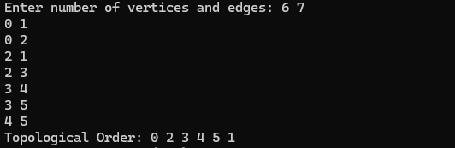

**LEETCODE: Course Schedule Code:**

typedef struct Node { int course;

struct Node *next;

} Node;

void addEdge(Node **graph, int src, int dest) {

Node *newNode = (Node *)malloc(sizeof(Node)); newNode->course = dest;

newNode->next = graph[src]; graph[src] = newNode;

}

bool canFinish(int numCourses, int** prerequisites, int prerequisitesSize, int* prerequisitesColSize) {

Node **graph = (Node **)calloc(numCourses, sizeof(Node *)); int *indegree = (int *)calloc(numCourses, sizeof(int));

for (int i = 0; i < prerequisitesSize; i++) {

int course = prerequisites[i][0]; int pre = prerequisites[i][1]; addEdge(graph, pre, course); indegree[course]++;

}

int *queue = (int *)malloc(numCourses * sizeof(int)); int front = 0, rear = 0;

for (int i = 0; i < numCourses; i++) { if (indegree[i] == 0) {

queue[rear++] = i;

}

}

int count = 0;

while (front < rear) {

int current = queue[front++]; count++;

Node *temp = graph[current]; while (temp != NULL) {

indegree[temp->course]--;

if (indegree[temp->course] == 0) { queue[rear++] = temp->course;

}

temp = temp->next;

}

}

for (int i = 0; i < numCourses; i++) { Node *temp = graph[i];

while (temp != NULL) { Node *next = temp->next; free(temp);

temp = next;

}

}

free(graph); free(indegree); free(queue);

return count == numCourses;

}

**Result:**

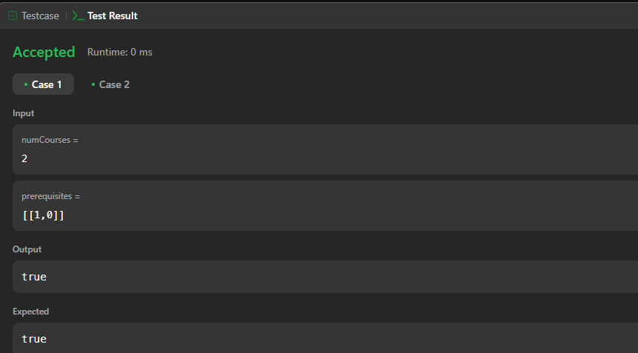

**Lab program 2 :**

**Implement Johnson Trotter algorithm to generate permutations.**

**Code:**

#include <stdio.h> #define SIZE 4

#define LEFT -1

#define RIGHT 1

int isMobile(int a[], int dir[], int i) {

if (dir[i] == LEFT && i != 0 && a[i] > a[i - 1]) return 1;

if (dir[i] == RIGHT && i != SIZE - 1 && a[i] > a[i + 1]) return 1;

return 0;

}

int getMobile(int a[], int dir[]) { int mobile = 0;

for (int i = 0; i < SIZE; i++) if (isMobile(a, dir, i))

if (a[i] > a[mobile] || !isMobile(a, dir, mobile)) mobile = i;

return isMobile(a, dir, mobile) ? mobile : -1;

}

// Swap elements and their directions void swap(int *x, int *y) {

int temp = *x;

*x = *y;

*y = temp;

}

void printPermutation(int a[]) { for (int i = 0; i < SIZE; i++)

printf("%d ", a[i]); printf("\n");

}

void johnsonTrotter() { int a[SIZE], dir[SIZE];

for (int i = 0; i < SIZE; i++) { a[i] = i + 1;

dir[i] = LEFT;

}

printPermutation(a);

while (1) {

int mobileIndex = getMobile(a, dir); if (mobileIndex == -1)

break;

int swapWith = mobileIndex + dir[mobileIndex]; swap(&a[mobileIndex], &a[swapWith]); swap(&dir[mobileIndex], &dir[swapWith]);

for (int i = 0; i < SIZE; i++) if (a[i] > a[swapWith])

dir[i] = -dir[i];

printPermutation(a);

}

}

int main() { johnsonTrotter(); return 0;

}

**Result:**

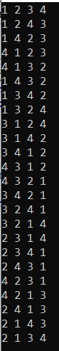

**Lab program 3 :**

**Sort a given set of N integer elements using Merge Sort technique and compute its time taken. Run the program for different values of N and record the time taken to sort.**

**Code:**

#include <stdio.h> #include <stdlib.h> #include <time.h>

void merge(int arr[], int left, int mid, int right) { int n1 = mid - left + 1, n2 = right - mid;

int L[n1], R[n2];

for (int i = 0; i < n1; i++) L[i] = arr[left + i];

for (int j = 0; j < n2; j++) R[j] = arr[mid + 1 + j];

int i = 0, j = 0, k = left;

while (i < n1 && j < n2) arr[k++] = (L[i] < R[j]) ? L[i++] : R[j++]; while (i < n1) arr[k++] = L[i++];

while (j < n2) arr[k++] = R[j++];

}

void mergeSort(int arr[], int left, int right) { if (left < right) {

int mid = left + (right - left) / 2; mergeSort(arr, left, mid); mergeSort(arr, mid + 1, right); merge(arr, left, mid, right);

}

}

void printArray(int arr[], int size) {

for (int i = 0; i < size; i++) printf("%d ", arr[i]); printf("\n");

}

int main() { int N;

printf("Enter the size of the array: "); scanf("%d", &N);

int arr[N]; srand(time(0));

for (int i = 0; i < N; i++) arr[i] = rand() % 10000;

printf("\nUnsorted array:\n"); printArray(arr, N);

clock_t start = clock(); mergeSort(arr, 0, N - 1); clock_t end = clock();

printf("\nSorted array:\n"); printArray(arr, N);

printf("\nTime taken to sort %d elements: %f seconds\n", N, ((double)(end - start)) / CLOCKS_PER_SEC);

return 0;

}

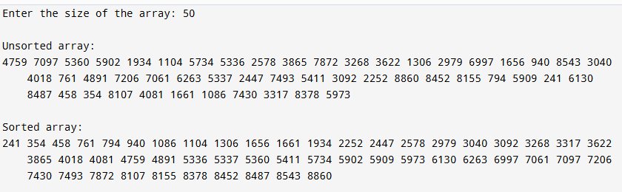**Result:**

**Lab program 4 :**

**Sort a given set of N integer elements using Quick Sort technique and compute its time taken.**

**Code:**

#include <stdio.h> #include <stdlib.h> #include <time.h>

// Function to swap two elements void swap(int *a, int *b) {

int temp = *a;

*a = *b;

*b = temp;

}

// Partition function for Quick Sort

int partition(int arr[], int low, int high) { int pivot = arr[high]; // pivot element

int i = (low - 1); // index of smaller element

for (int j = low; j < high; j++) { if (arr[j] <= pivot) {

i++;

swap(&arr[i], &arr[j]);

}

}

swap(&arr[i + 1], &arr[high]); return (i + 1);

}

// Quick Sort function

void quickSort(int arr[], int low, int high) { if (low < high) {

int pi = partition(arr, low, high); // partitioning index quickSort(arr, low, pi - 1); // Recursively sort left subarray quickSort(arr, pi + 1, high); // Recursively sort right subarray

}

}

// Main function int main() {

int n;

// Input the size of the array printf("Enter number of elements: "); scanf("%d", &n);

int arr[n];

// Seed the random number generator srand(time(0));

// Generate random numbers for the array printf("Generated array: ");

for (int i = 0; i < n; i++) {

arr[i] = rand() % 1000; // Generate random numbers between 0 and 999 printf("%d ", arr[i]);

}

printf("\n");

// Measure time taken for sorting clock_t start = clock();

quickSort(arr, 0, n - 1);

clock_t end = clock();

double time_taken = ((double)(end - start)) / CLOCKS_PER_SEC;

// Output the sorted array printf("Sorted array: "); for (int i = 0; i < n; i++) {

printf("%d ", arr[i]);

}

printf("\n");

// Output the time taken

printf("Time taken to sort: %f seconds\n", time_taken);

return 0;

}

**Result:**

**LEETCODE: 3Sum**

**Code:**

var threeSum = function (nums) {

nums.sort((a, b) => a - b); const op = [];

for (let i = 0; i < nums.length; i++) {

if (i > 0 && nums[i] === nums[i - 1]) continue; const target = -nums[i];

let left = i + 1, right = nums.length - 1; while (left < right) {

const current_sum = nums[left] + nums[right]; if (current_sum === target) {

op.push([nums[i], nums[left], nums[right]]);

while (left < right && nums[left] === nums[left + 1]) left++; while (left < right && nums[right] === nums[right - 1]) right--; left++;

right--;

} else if (current_sum < target) { left++;

} else {

right--;

}

}

}

return op;

};

**Result:**

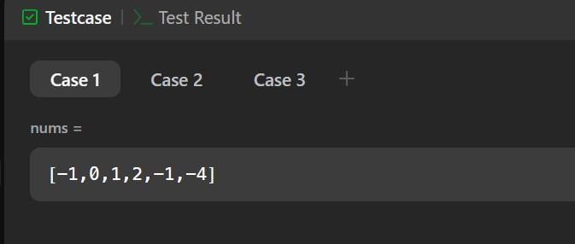

**Lab program 5 :**

**Sort a given set of N integer elements using Heap Sort technique and compute its time taken.**

**Code:**

#include <stdio.h> #include <stdlib.h> #include <time.h>

// Function to swap two elements void swap(int *x, int *y) {

int temp = *x;

*x = *y;

*y = temp;

}

// Function to heapify a subtree rooted at index i void heapify(int arr[], int n, int i) {

int largest = i;

int left = 2 * i + 1; // left child int right = 2 * i + 2; // right child

// If left child is larger than root

if (left < n && arr[left] > arr[largest]) largest = left;

// If right child is larger than root

if (right < n && arr[right] > arr[largest]) largest = right;

// If largest is not root if (largest != i) {

swap(&arr[i], &arr[largest]);

heapify(arr, n, largest); // Recursively heapify the affected subtree

}

}

// Main function to implement heap sort void heapSort(int arr[], int n) {

// Build a max heap

for (int i = n / 2 - 1; i >= 0; i--) { heapify(arr, n, i);

}

// One by one extract elements from the heap for (int i = n - 1; i >= 1; i--) {

// Move the current root to the end swap(&arr[0], &arr[i]);

// Call heapify on the reduced heap heapify(arr, i, 0);

}

}

// Function to print an array

void printArray(int arr[], int size) { for (int i = 0; i < size; i++) {

printf("%d ", arr[i]);

}

printf("\n");

}

int main() {

// Array to be sorted

int arr[] = {12, 11, 13, 5, 6, 7};

int n = sizeof(arr) / sizeof(arr[0]);

// Start measuring time clock_t start = clock();

// Perform heap sort heapSort(arr, n);

// Stop measuring time clock_t end = clock();

// Print sorted array printf("Sorted array: "); printArray(arr, n);

// Compute and print the time taken

double time_taken = ((double)(end - start)) / CLOCKS_PER_SEC; printf("Time taken to sort: %f seconds\n", time_taken);

return 0;

}

**Result:**



**Lab program 6 :**

**Implement 0/1 Knapsack problem using dynamic programming.**

**Code:**

#include <stdio.h>

// Function to get the maximum of two numbers int max(int a, int b) {

return (a > b) ? a : b;

}

// Function to solve 0/1 Knapsack problem using Dynamic Programming int knapsack(int W, int wt[], int val[], int n) {

int dp[n+1][W+1]; // dp[i][w] stores max value for i items and weight limit w

// Build the dp table in bottom-up manner for (int i = 0; i <= n; i++) {

for (int w = 0; w <= W; w++) { if (i == 0 || w == 0)

dp[i][w] = 0; // Base case: no items or no weight capacity else if (wt[i-1] <= w)

dp[i][w] = max(val[i-1] + dp[i-1][w - wt[i-1]], dp[i-1][w]);

// Include the item or skip it, take the max else

dp[i][w] = dp[i-1][w]; // Can't include the item, skip it

}

}

return dp[n][W]; // Return max value for n items and total weight W

}

int main() {

int val[] = {60, 100, 120}; // Values of items int wt[] = {10, 20, 30}; // Weights of items

int W = 50; // Maximum weight capacity int n = sizeof(val)/sizeof(val[0]); // Number of items

int maxValue = knapsack(W, wt, val, n); // Call the knapsack function printf("Maximum value in knapsack = %d\n", maxValue);

return 0;

}

**Result:**



**LEETCODE: Fibonacci Number Code:**

int fib(int n) {

if (n == 0) return 0;

if (n == 1) return 1;

int a = 0, b = 1, c;

// Calculate Fibonacci iteratively for (int i = 2; i <= n; i++) {

c = a + b; // Fibonacci relation

a = b; // Update a to previous b

b = c; // Update b to current Fibonacci number

}

return b; // Return the nth Fibonacci number

}

**Result:**

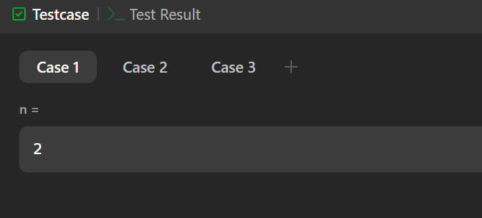

**Lab program 7 :**

**Implement All Pair Shortest paths problem using Floyd’s algorithm.**

**Code:**

#include <stdio.h> #include <stdlib.h>

#define INF 99999 // A large value representing infinity

void floydWarshall(int graph[][4], int V) {

// dist[][] will be the output matrix that will store the shortest distance between every pair of vertices

int dist[V][V];

// Initialize the distance matrix with the given graph values for (int i = 0; i < V; i++) {

for (int j = 0; j < V; j++) {

if (graph[i][j] == 0 && i != j) { dist[i][j] = INF; // No path

} else {

dist[i][j] = graph[i][j];

}

}

}

// Floyd-Warshall algorithm: update the distance matrix for (int k = 0; k < V; k++) {

for (int i = 0; i < V; i++) { for (int j = 0; j < V; j++) {

if (dist[i][j] > dist[i][k] + dist[k][j]) {

dist[i][j] = dist[i][k] + dist[k][j];

}

}

}

}

// Print the shortest distance matrix

printf("The shortest distances between every pair of vertices are:\n"); for (int i = 0; i < V; i++) {

for (int j = 0; j < V; j++) { if (dist[i][j] == INF) {

printf("INF ");

} else {

printf("%d ", dist[i][j]);

}

}

printf("\n");

}

}

int main() {

// Adjacency matrix representation of the graph

// graph[i][j] = weight of edge from vertex i to vertex j

// 0 means no edge (in this case, we represent infinity with a large value)

int graph[4][4] = {

{0, 3, INF, 7},

{8, 0, 2, INF},

{5, INF, 0, 1},

{2, INF, INF, 0}

};

int V = 4; // Number of vertices in the graph

// Call the Floyd-Warshall algorithm to find shortest paths floydWarshall(graph, V);

return 0;

}

**Result:**

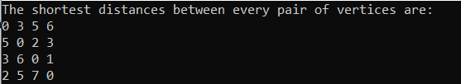

**LEETCODE: Shortest Path Visiting All Nodes Code:**

#include <stdio.h> #include <stdlib.h> #include <string.h> #include <stdbool.h>

#define MAXN 12

#define MAXQ (1 << MAXN) * MAXN

typedef struct { int node;

int mask; int dist;

} State;

int shortestPathLength(int** graph, int graphSize, int* graphColSize) { int allVisited = (1 << graphSize) - 1;

bool visited[MAXN][1 << MAXN] = { false };

State queue[MAXQ]; int front = 0, rear = 0;

// Initialize queue with each node as starting point for (int i = 0; i < graphSize; i++) {

int mask = 1 << i;

queue[rear++] = (State){i, mask, 0}; visited[i][mask] = true;

}

while (front < rear) {

State curr = queue[front++];

if (curr.mask == allVisited) { return curr.dist;

}

for (int i = 0; i < graphColSize[curr.node]; i++) { int neighbor = graph[curr.node][i];

int nextMask = curr.mask | (1 << neighbor);

if (!visited[neighbor][nextMask]) { visited[neighbor][nextMask] = true;

queue[rear++] = (State){neighbor, nextMask, curr.dist + 1};

}

}

}

return -1; // Should never reach here

}

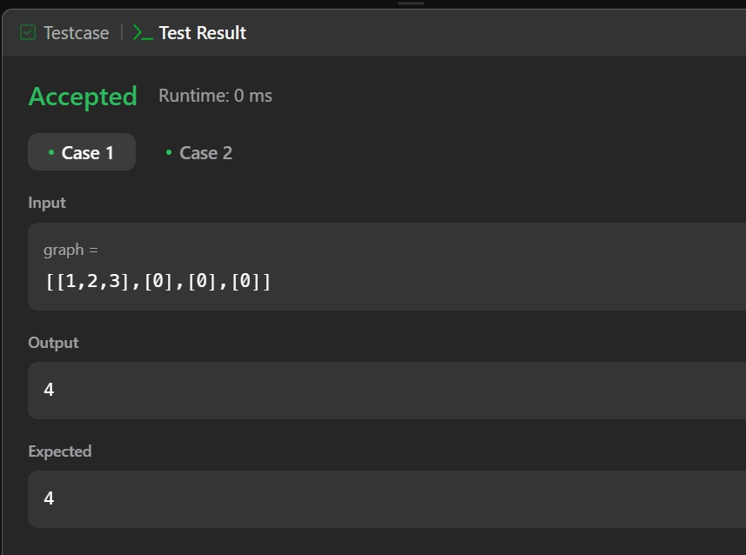**Result:**

**Lab program 8 :**

**Find Minimum Cost Spanning Tree of a given undirected graph using Prim’s algorithm.**

**Code:**

#include <stdio.h> #include <limits.h> #include <stdbool.h>

#define V 5

int minKey(int key[], bool mstSet[]){ int min= INT_MAX, min_index;

for(int v=0; v<V; v++){ if(!mstSet[v] && key[v]<min){

min = key[v]; min_index=v;

}

}

return min_index;

}

void primMST(int graph[V][V]){ int key[V];

int parent[V]; bool mstSet[V];

for (int i = 0; i < V; i++)

key[i] = INT_MAX, mstSet[i] = false;

key[0] = 0; // Start from node 0 parent[0] = -1;

for (int count = 0; count < V - 1; count++) {

int u = minKey(key, mstSet); // Pick min weight vertex mstSet[u] = true;

for (int v = 0; v < V; v++)

if (graph[u][v] && !mstSet[v] && graph[u][v] < key[v]) parent[v] = u, key[v] = graph[u][v];

}

printMST(parent,graph);

}

void printMST(int parent[], int graph[V][V]){ printf("Prim's MST: \n");

for(int i=1; i<V; i++){

printf("%d---%d==%d\n",parent[i],i,graph[i][parent[i]]);

}

}

int main() {

int graph[V][V] = {

{0, 2, 0, 6, 0},

{2, 0, 3, 8, 5},

{0, 3, 0, 0, 7},

{6, 8, 0, 0, 9},

{0, 5, 7, 9, 0}

};

primMST(graph);

return 0;

}

**Result:**

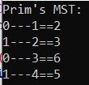

**Find Minimum Cost Spanning Tree of a given undirected graph using Kruskal’s algorithm.**

**Code:** #include<stdio.h> #include<conio.h>

int find(int v,int parent[10])

{

while(parent[v]!=v)

{

v=parent[v];

}

return v;

}

void union1(int i,int j,int parent[10])

{

if(i<j)

parent[j]=i; else

parent[i]=j;

}

void kruskal(int n,int a[10][10])

{

int count,k,min,sum,i,j,t[10][10],u,v,parent[10]; count=0;

k=0;

sum=0; for(i=0;i<n;i++)

parent[i]=i; while(count!=n-1)

{

min=999; for(i=0;i<n;i++)

{

for(j=0;j<n;j++)

{

if(a[i][j]<min && a[i][j]!=0)

{

min=a[i][j]; u=i;

v=j; .

}

}

}

i=find(u,parent); j=find(v,parent);

if(i!=j)

{

union1(i,j,parent); t[k][0]=u;

t[k][1]=v; k++;

count++; sum=sum+a[u][v];

}

a[u][v]=a[v][u]=999;

}

if(count==n-1)

{

printf("spanning tree\n"); for(i=0;i<n-1;i++)

{

printf("%d %d\n",t[i][0],t[i][1]);

}

printf("cost of spanning tree=%d\n",sum);

}

else

printf("spanning tree does not exist\n");

}

void main()

{

int n,i,j,a[10][10]; clrscr();

printf("enter the number of nodes\n"); scanf("%d",&n);

printf("enter the adjacency matrix\n"); for(i=0;i<n;i++)

for(j=0;j<n;j++) scanf("%d",&a[i][j]);

kruskal(n,a);

getch();

}

**Result:**

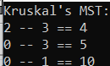

**Lab program 9 :**

**Implement Fractional Knapsack using Greedy technique.**

**Code:** #include<stdio.h> int main()

{

float weight[50],profit[50],ratio[50],Totalvalue,temp,capacity,amount; int n,i,j;

printf("Enter the number of items :"); scanf("%d",&n);

for (i = 0; i < n; i++)

{

printf("Enter Weight and Profit for item[%d] :\n",i); scanf("%f %f", &weight[i], &profit[i]);

}

printf("Enter the capacity of knapsack :\n"); scanf("%f",&capacity);

for(i=0;i<n;i++) ratio[i]=profit[i]/weight[i];

for (i = 0; i < n; i++)

for (j = i + 1; j < n; j++) if (ratio[i] < ratio[j])

{

temp = ratio[j]; ratio[j] = ratio[i]; ratio[i] = temp;

temp = weight[j]; weight[j] = weight[i];

weight[i] = temp;

temp = profit[j]; profit[j] = profit[i]; profit[i] = temp;

}

printf("Knapsack problems using Greedy Algorithm:\n"); for (i = 0; i < n; i++)

{

if (weight[i] > capacity) break;

else

{

Totalvalue = Totalvalue + profit[i]; capacity = capacity - weight[i];

}

}

if (i < n)

Totalvalue = Totalvalue + (ratio[i]*capacity); printf("\nThe maximum value is :%f\n",Totalvalue); return 0;

}

**Result:**

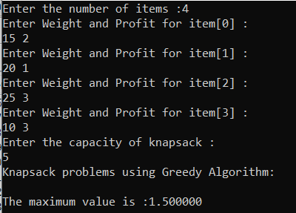

**LEETCODE: Largest Odd Number in String Code:**

char* largestOddNumber(char* num) { int len = strlen(num);

// Traverse from the end to find the rightmost odd digit for (int i = len - 1; i >= 0; i--) {

if ((num[i] - '0') % 2 == 1) {

// Temporarily terminate the string at the right place num[i + 1] = '\0';

return num;

}

}

return ""; // No odd digit found

}

**Result:**

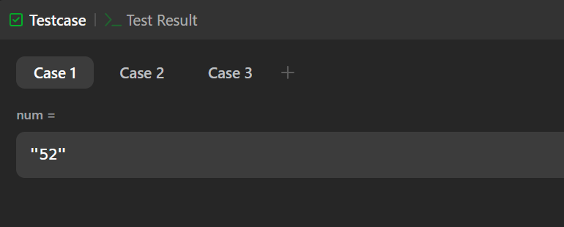

**Lab program 10 :**

**From a given vertex in a weighted connected graph, find shortest paths to other vertices using Dijkstra’s algorithm.**

**Code:** #include<stdio.h> #include<conio.h>

void dijkstra(int n,int cost[10][10],int src)

{

int i,j,u,dis[10],vis[10],min; for(i=1;i<=n;i++)

{

dis[i]=cost[src][i]; vis[i]=0;

}

vis[src]=1; for(i=1;i<=n;i++)

{

min=999; for(j=1;j<=n;j++)

{

if(vis[j]==0 && dis[j]<min)

{

min=dis[j]; u=j;

}

}

vis[u]=1; for(j=1;j<=n;j++)

{

if(vis[j]==0 && dis[u]+cost[u][j]<dis[j])

{

dis[j]=dis[u]+cost[u][j];

}

}

}

printf("shortest path\n"); for(i=1;i<=n;i++)

printf("%d->%d=%d\n",src,i,dis[i]);

}

void main()

{

int src,j,cost[10][10],n,i; clrscr();

printf("enter the number of vertices\n"); scanf("%d",&n);

printf("enter the cost adjacency matrix\n"); for(i=1;i<=n;i++)

for(j=1;j<=n;j++) scanf("%d",&cost[i][j]);

printf("enter the source vertex\n"); scanf("%d",&src); dijkstra(n,cost,src);

getch();

}

**Result:**



**Lab program 11 :**

**Implement “N-Queens Problem” using Backtracking.**

**Code:**

#include <stdio.h>

#define N 4

int board[N][N];

int solutionCount = 0;

int isSafe(int row, int col) { for (int i = 0; i < row; i++) {

if (board[i][col]) return 0;

if (col - (row - i) >= 0 && board[i][col - (row - i)]) return 0; if (col + (row - i) < N && board[i][col + (row - i)]) return 0;

}

return 1;

}

void printBoard() {

printf("Solution %d:\n", ++solutionCount); for (int i = 0; i < N; i++) {

for (int j = 0; j < N; j++)

printf("%c ", board[i][j] ? 'Q' : '.'); printf("\n");

}

printf("\n");

}

void solve(int row) { if (row == N) {

printBoard(); // Found one solution return;

}

for (int col = 0; col < N; col++) { if (isSafe(row, col)) {

board[row][col] = 1;

solve(row + 1); // Try next row board[row][col] = 0; // Backtrack

}

}

}

int main() { solve(0);

if (solutionCount == 0) printf("No solution found\n");

return 0;

}

**Result:**

